# Project Change Request Document [IPMS]

**Document location**

| Location |
| --- |
| NIT, Jublee Hills, Hyderabad, India |

**Author**

| Position | Name | Contact no |
| --- | --- | --- |
| Technical Manager | Dilshad | 9911859088 |

**Revision history**

| Version | Issue date | Author/editor | Description/Summary of changes |
| --- | --- | --- | --- |
| 1.0.0# | 15-06-2023 | Dilshad | **Business rule changes regarding Vessel Arrival for respective port** |
|  |  |  |  |

**Reviewed by**

| Version | Issue date | Name | Position / Designation | Review date |
| --- | --- | --- | --- | --- |
| 1.0.0# | 15-06-2023 | Venkata Tilla | Business Analyst | 15-06-2023 |
| 1.0.1# | ----- | ----- | ----- | ----- |
|  |  |  |  |  |

**Approvals**

| Version | Issue date | Name | Position/ Designation | Approval date |
| --- | --- | --- | --- | --- |
| 1.0.0# | 15-06-2023 | **SAMBA G** | HOD/IT Director/Project Head |  |
| 1.0.1# | ------ | ------ |  |  |

**Related documents**

| Document | Location |
| --- | --- |
| Project Change Request Document[IPMS] | NIT, Jublee Hills, Hyderabad, India |

|  |  |  |  |  |  |  |
| --- | --- | --- | --- | --- | --- | --- |
| **1. SUBMITTER - GENERAL INFORMATION** | | | | | | |
| **CR. No.** | *IPMS-0001* | | | | | |
| **Type of CR** | Enhancement | | Defect | **Others [Business Rule Changes]** | | |
| **Project/Program/Initiative** | *IPMS* | | | | | |
| **Submitter Name** | **Dilshad** | | | | | |
| **Brief Description of Request** | **Business rule changes regarding Vessel Arrival for respective port to post into SAP** | | | | | |
| **Date Submitted** |  | | | | | |
| **Date Required** |  | | | | | |
| **Priority** | Low | **Medium** | | High | | Mandatory |
| **Reason for Change** | *As Discuss in Meeting on 14 June 2023* | | | | | |
| **Other Artifacts Impacted** | ***The Page will impact after changes. Kindly View Detail*** | | | | | |
| **Assumptions and Notes** |  | | | | | |
| **Comments by Business Analyst** |  | | | | | |
| **Attachments or References** | Yes | No | |  | | |
| **Link:** | | | | | |
| **Approval Signature** |  | | | **Date Signed** |  | |

|  |  |  |  |  |
| --- | --- | --- | --- | --- |
| **2.TECHNICAL LEAD - INITIAL ANALYSIS** | | | | |
| **Hour Impact** | *hrs* |  | | |
| **Duration Impact** | *days* |  | | |
| **Schedule Impact** | *days* |  | | |
| **Comments** |  | | | |
| **Recommendations** |  | | | |
| **Approval Signature** |  | | **Date Signed** |  |

|  |  |  |  |  |  |  |
| --- | --- | --- | --- | --- | --- | --- |
| **3.PROJECT MANAGER – DECISION** | | | | | | |
| **Decision** | Approved | Approved with Conditions | | Rejected | | More Info |
| **Decision Date** |  | | | | | |
| **Decision Explanation** |  | | | | | |
| **Conditions** |  | | | | | |
| **Approval Signature** |  | | **Date Signed** | |  | |

**Details**

There are two pages where can be implement this business logic.

1. Arrival Notification list and New Entry
   1. We can check the condition to display the arrival list with respective Port option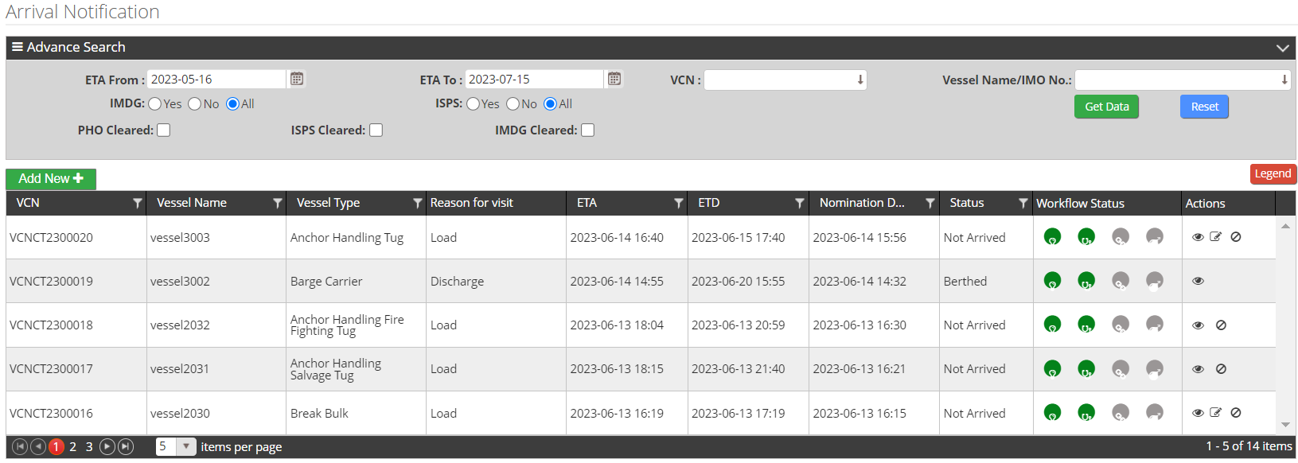
2. Posting xml Data into SAP .Which return SAP Vessel No with **<KENNUR> XXXXXX </ KENNUR >**
   1. Automate posting
   2. Manual posting

After Vessel posting into SAP it return the SAP vessel No. which is used for Arrival posting in SAP as **<KENNUR> XXXXXX </ KENNUR >.** Where we have to implement this business rule.

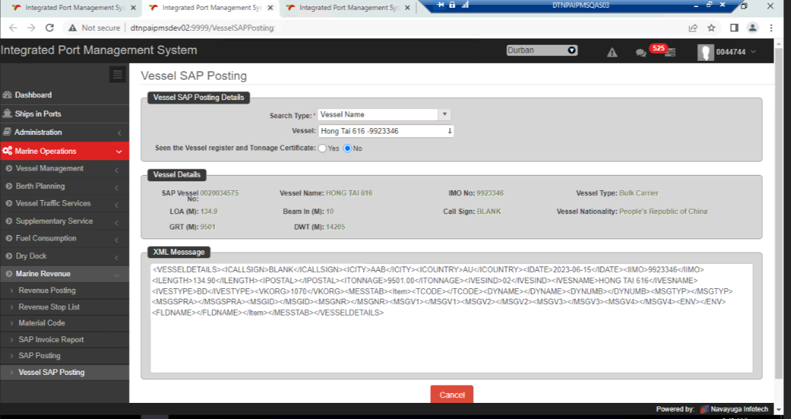

1. Automate posting

According business rule, if it is passed 6 days it will auto post with SAP. Before 6 days we will post manually to SAP.

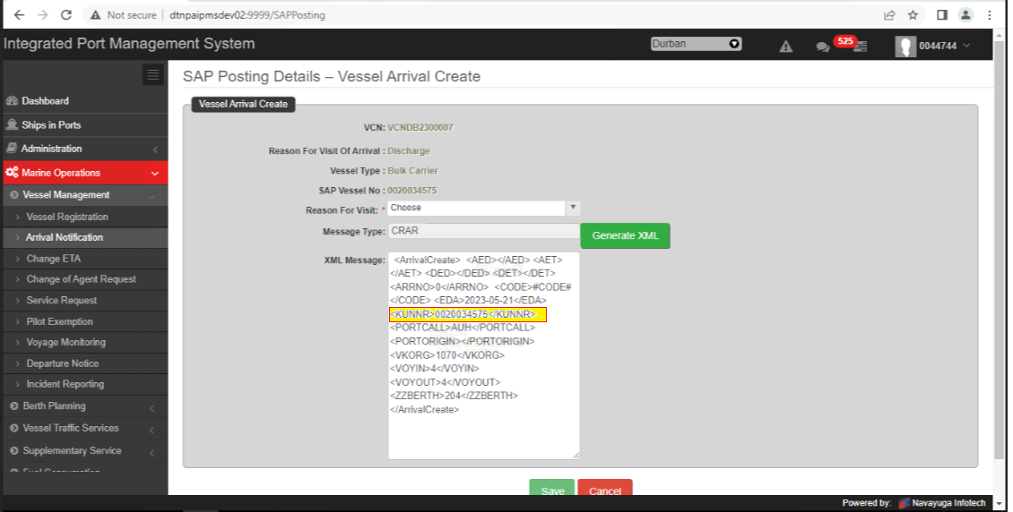

**Impact**

Before doing changes business domain has affected.

**Doubt**

In which place we will do changes.

1. Arrival entry in IPMS
2. Arrival Posting in SAP VIA IPMS